**HMIS API Build System High Level Design**

Draft 0.1

Last Updated: March 14, 2015

**Abstract**

This document describes the scope, high level design of the build system for the HMIS.

Contents

2 Version History 3

3 References 3

4 Abbreviations and Acronyms 3

5 Assumptions, Issues and Risks 4

5.1 Assumptions 4

5.2 Issues 4

5.3 Risks 4

6 Introduction 5

6.1 Scope 5

6.2 Out of Scope 5

7 Solution Design 5

7.1.1 Outreach Mobile UI 5

7.1.2 OAuth Provider 5

7.1.3 Service 5

7.1.4 Database 5

7.2 Security Model 5

7.3 Interface Specification and data mappings 6

7.3.1 Generic Response Type 6

7.3.2 Authentication and Authorization Service 6

7.3.3 Client Service 6

7.3.4 Gender Service 10

7.3.5 Race Service 12

7.3.6 Ethnicity Service 14

8 Implementation Strategy 17

8.1 Technology Selection 17

# Version History

|  |  |  |  |
| --- | --- | --- | --- |
| Version | Date | Author | Description |
| Draft 0.1 | 03-15-2015 | Ashaar Riaz | Initial Draft |

Table 1: Version History

# References

|  |  |  |  |  |
| --- | --- | --- | --- | --- |
| S.No. | Version | Source | Author | Document Name |
|  |  |  |  |  |
|  |  |  |  |  |
|  |  |  |  |  |
|  |  |  |  |  |
|  |  |  |  |  |
|  |  |  |  |  |

Table 2: References

# Abbreviations and Acronyms

|  |  |
| --- | --- |
| Abbreviation/Acronym | Description |
|  |  |
|  |  |
|  |  |
|  |  |
|  |  |
|  |  |
|  |  |
|  |  |
|  |  |

Table 3: Abbreviations and Acronyms

# Assumptions, Issues and Risks

## Assumptions

|  |  |  |  |
| --- | --- | --- | --- |
| S.No. | Assumption | Comments | Status |
|  |  |  |  |
|  |  |  |  |
|  |  |  |  |

Table 4: Assumptions

## Issues

|  |  |  |  |
| --- | --- | --- | --- |
| S.No. | Assumption | Comments | Status |
|  |  |  |  |
|  |  |  |  |

Table 5: Issues

## Risks

|  |  |  |  |
| --- | --- | --- | --- |
| S.No. | Assumption | Comments | Status |
|  |  |  |  |
|  |  |  |  |
|  |  |  |  |

Table 6: Risks

# Introduction

Ant is being used for compilation and deployment of the application.

## Build System

### Build File

Ant file have three main task. Ant clean, ant compile and ant deploy.

#### ant clean

Clean command will delete all the folders it has created during compilation and deployment task.

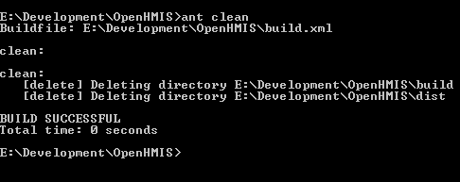

#### ant Compile

Compile command will created the build, dist directories.

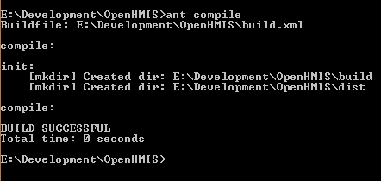

#### ant deploy

Deploy will create the war file and copy it to the tomcat webapp directory.

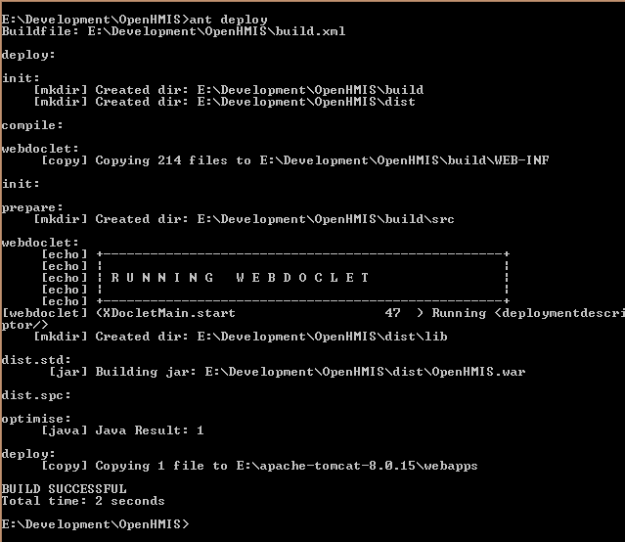

#### Root Location (root.dir)

Build File

Build Properties

Configuration Properties

Configuration File

The location on the hard drive where the source code is downloaded from the repository.

#### Source Location (src.dir)

The location of the source folder. It is the src folder at root location.

#### Configuration Location (Config.dir)

Location of the configuration folder. It can be anywhere in the system. In the repository it is at the same location as the source location. The folder contain the files that is called by the build file.

#### Build Folder Location (build.dir)

Location of the build folder. This file contains all the files that are in the war files. If you want to see what is in the war file, you can see in this folder.

#### Library Folder Location (ext.dir)

Location of the library folder. This directory contains all the jar files needed to compile the source code.

#### Classed Folder (classes.dir)

All the class files will be in this folder.

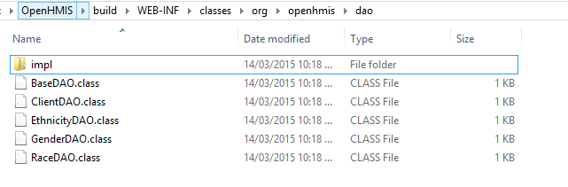

Class files in the dao folder. Similarly you can see the impl folder or any other folder for the class files.

#### Dist Folder (dist.dir)

This folder contains the war file. This the copy of the same file that is deployed on the web/application server.

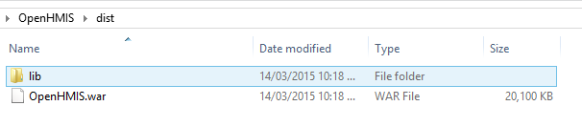

#### webroot.dir

Location of the Webroot folder.

### Configuration Properties

#### Src.dir

Location of the source folder relative to the configuration folder. If you want to change the location of the configuration folder then you need to update it.

#### Resources.dir

Location of the resource folder. This contains the private key for oauth2 authorization.

#### test-src.dir

Location of the test folder. All the unit test will be saved in this directory.

#### webroot.dir

Location of the web root directory relative to the configuration folder. When you change the location of the configuration folder you need to update the value of this.

#### web-inf.dir

Location of the WEB-INF directory. You don’t need to change the value of this property if you change the location of the configuration folder. The value of this property is relative to the webroot.dir.

#### classes.dir

Location of the classed directory in the web-inf.dir folder.

#### ext.dir

Location of the jar file. These files will be used during compilation. If you want to add a new jar file in the system, you need to copy here.

#### build.dir

Location of the build folder relative to the configuration folder.

#### build.web-inf.dir

Location of the WEB-INF folder in the build folder.

#### generated-src.dir

Source will be copied into this folder.

#### meta-inf.dir

Location of the META-INF folder.

#### dist.dir

Location of the distribution folder relative to the configuration folder.

#### dist-lib.dir

Location of the library in the distribution folder. This folder will contains all the library in the system.

#### docs.dir

All the documents will be saved in this folder.

#### buildnotes.dir

All the build notes will be saved in this folder.

#### tomcat-version

Location where the tomcat has been installed or unzipped.

#### tomcat.home

This is same as the tomcat version we can break the tomcat home into version and base. In case it would be the base and version.

#### tomcat.instance

Name of the folder where the war file is deployed in the tomcat.

#### deploy.dir

Name of the path of the deployment folder.

#### deploy-lib.dir

Location of the library folder in Tomcat.